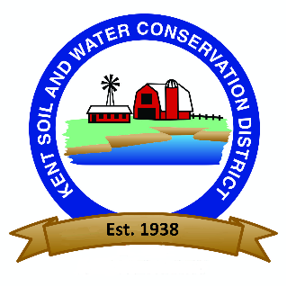

Kent Soil and Water Conservation District
Erosion and Sediment Control Review Fees
(Effective August 1, 2022)

TYPE OF PLAN | Application Fee |  | Review Fee
Standard 5000 sq. ft. to 20,000 sq ft | $100.00 | + | $100.00
Detailed over 20,000 sq ft | $200.00 | + | $200/ac
Forest Harvest | $100.00 | + | $20/ac
Shoreline | $150.00 | + | $150.00
Agricultural Structure | $100.00 | + | $50.00
Renewal (before 3-year expiration) | Waived | + | $200.00
Municipal (Town/County) | Waived | + | $50/ac

Where Review Fees are charged per acre, the fee will be charged in increments of one tenth of an acre.

